PROGRAM 1 : Write a java program to take input as a command line argument.Your name,course,universityrollno and semester. Display the information.

Name:

UniversityRollNo:

Course:

SOURCE CODE :

import java.util.Scanner;

public class hello

{

public static void main(String[] args)

{

String name,course;

int rollNo,sem;

Scanner sc=new Scanner(System.in);

if(args.length<4)

{

System.out.println("Enter all the details");

System.exit(0);

}

name = args[0];

course=args[1];

sc.nextLine();

rollNo=Integer.parseInt(args[2]);

sem=Integer.parseInt(args[3]);

System.out.println("Your name is "+name);

System.out.println("Your Couse is "+course);

System.out.println("Your Roll number is "+rollNo);

System.out.println("Your Semester is "+sem);

}

};

OUTPUT :

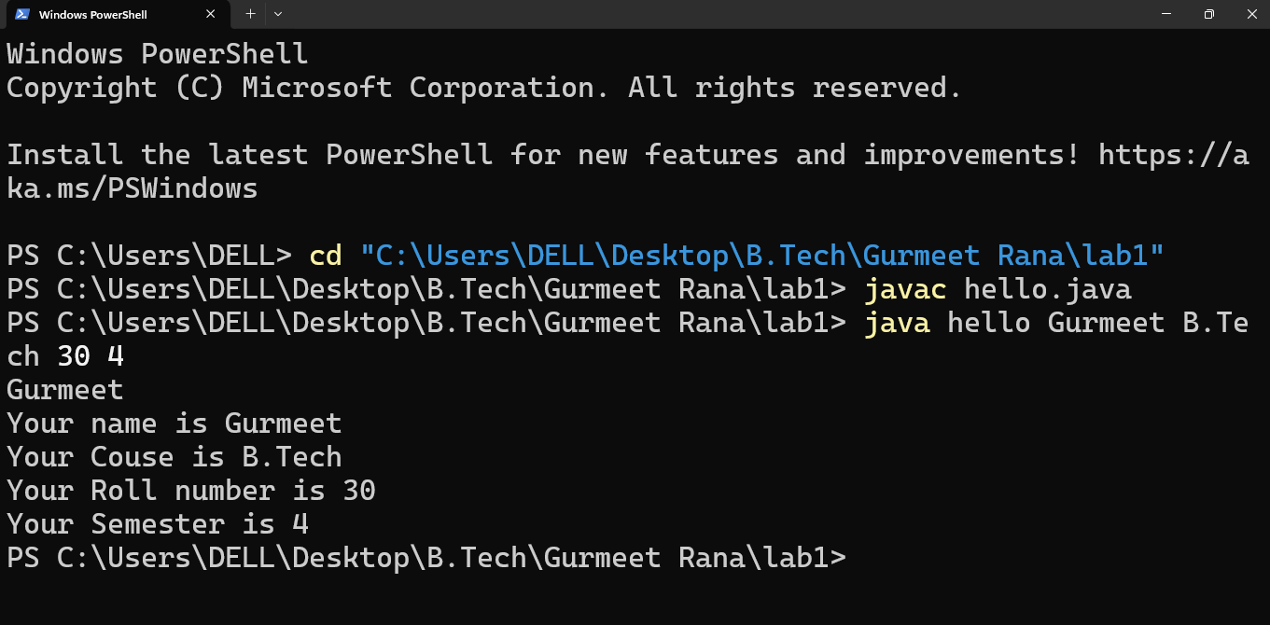

PROGRAM 2 : Using the switch statement, write a menu-driven program to calculate the maturity amount of a bank deposit.The user is

(i) Term Deposit

(ii) Recurring Deposit

For option (i) accept Principal (p), rate of interest ® and time period in years (n). Calculate and output the

maturity amount (a) receivable using the formula a =p[1 + r / 100]n.

For option (ii) accept monthly installment (p), rate of interest (r) and time period in months (n). Calculate and

output the maturity amount (a) receivable using the formula a = p \* n + p \* n(n + 1) / 2 \* r / 100 \* 1 / 12.

For an incorrect option, an appropriate error message should be displayed.

SOURCE CODE :

import java.util.Scanner;

public class hello

{

public static void main(String[] args)

{

String name,course;

int rollNo,sem;

Scanner sc=new Scanner(System.in);

if(args.length<4)

{

System.out.println("Enter all the details");

System.exit(0);

}

name = args[0];

course=args[1];

sc.nextLine();

rollNo=Integer.parseInt(args[2]);

sem=Integer.parseInt(args[3]);

System.out.println("Your name is "+name);

System.out.println("Your Couse is "+course);

System.out.println("Your Roll number is "+rollNo);

System.out.println("Your Semester is "+sem);

}

};

OUTPUT :

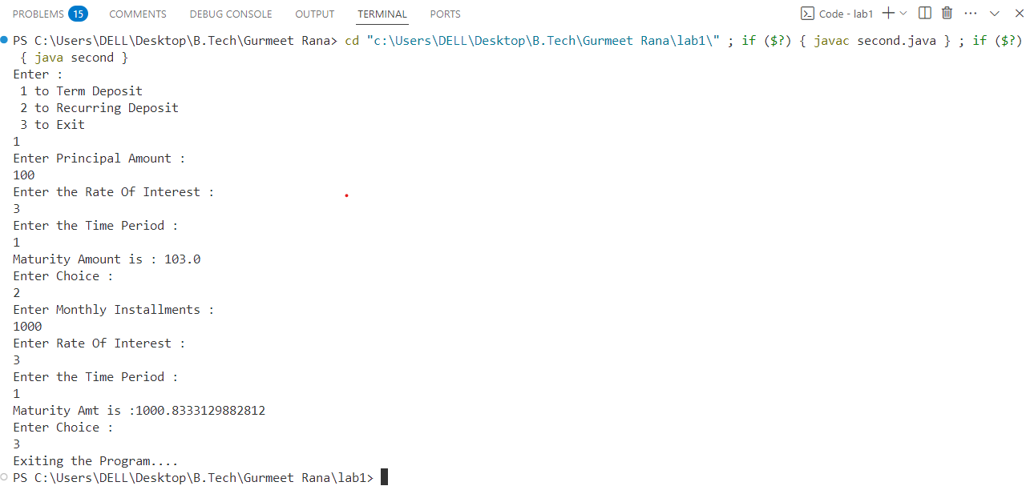

PROGRAM 3 : Program to find if the given numbers are Friendly pair or not (Amicable or not).Friendly Pair are two or more numbers with a common abundance.

SOURCE CODE :

import java.util.Scanner;

public class third {

private static int findDivisorSum(int num)

{

int sum=0;

for(int i=1;i<=num/2;i++)

{

if(num%i==0)

{

sum+=i;

}

}

return sum;

}

public static void main(String [] args)

{

int num1,num2;

Scanner sc=new Scanner(System.in);

System.out.println("Enter first number :");

num1=sc.nextInt();

System.out.println("Enter second number :");

num2=sc.nextInt();

int divSum1=findDivisorSum(num1);

int divSum2=findDivisorSum(num2);

if(divSum1/num1 == divSum2/num2)

{

System.out.println(num1+" AND "+num2+" ARE "+"Friendly Number");

}

else

{

System.out.println(num1+"AND"+num2+"ARE"+"NOT Friendly Number");

}

System.out.println("Exiting the Program....");

}

}

OUTPUT :

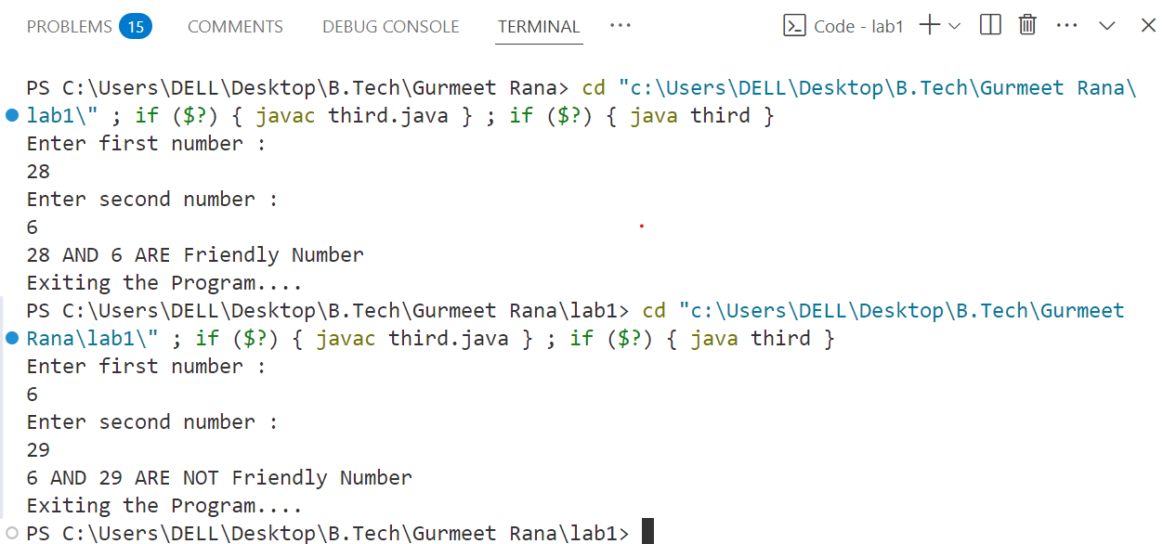

PROGRAM 4 : Program to replace all 0's with 1 in a given integer. Given an integer as an input, all the 0's in the number has to be replaced with 1.

SOURCE CODE :

import java.util.Scanner;

public class forth {

public static void main(String [] args)

{

int number;

Scanner sc=new Scanner(System.in);

System.out.println("Enter the number : ");

number=sc.nextInt();

int temp=0;

while(number>0)

{

int digit=number%10;

if(digit==0)

{

temp=temp\*10+1;

}

else{

temp=temp\*10+digit;

}

number/=10;

}

int ans=0;

while(temp>0)

{

ans=ans\*10+temp%10;

temp/=10;

}

System.out.println("New Number is : "+ans);

}

}

OUTPUT :

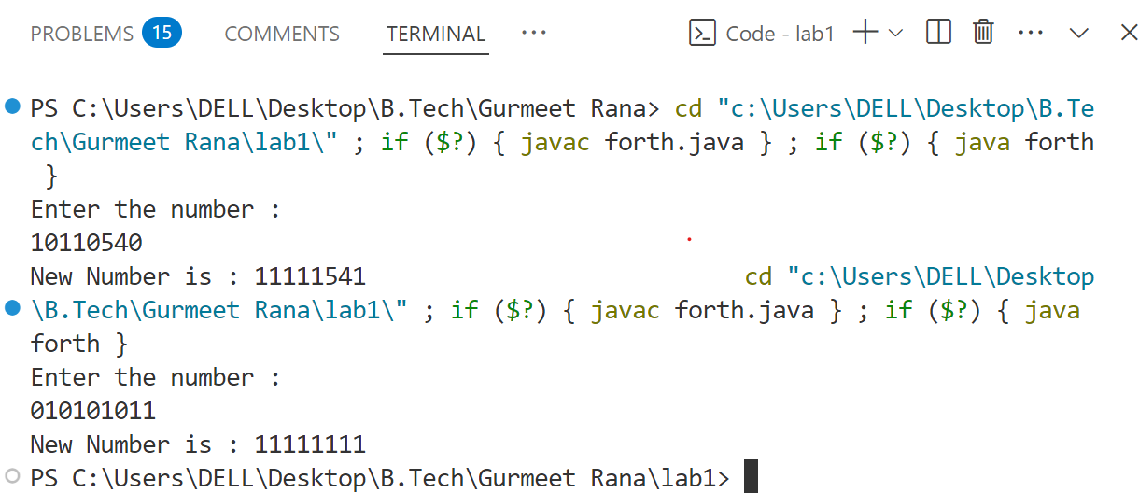

PROGRAM 5 : Printing an array into Zigzag fashion. Suppose you were given an array of integers, and you are told to sort the integers in a zigzag pattern. In general, in a zigzag pattern, the first integer is less than the second integer, which is greater than the third integer, which is less than the fourth integer, and so on. Hence, the converted array

should be in the form of e1 < e2 > e3 < e4 > e5 < e6.

SOURCE CODE :

import java.util.Scanner;

public class fifth {

public static void swap(int a,int b)

{

a=a^b;

b=b^a;

a=a^b;

}

void show(int arr[],int n)

{

for(int x:arr)

{

System.out.println(x);

}

}

void zigZagSort(int arr[],int n)

{

boolean flag=false;

for(int i=0;i<n-1;i++)

{

if(flag)

{

if(arr[i+1]<arr[i])

{

int temp=arr[i+1];

arr[i+1]=arr[i];

arr[i]=temp;

}

}

else

{

if(arr[i+1]>arr[i])

{

int temp=arr[i+1];

arr[i+1]=arr[i];

arr[i]=temp;

}

}

}

}

public static void main(String [] args)

{

int n;

Scanner sc=new Scanner(System.in);

System.out.println("Enter the size of the array : ");

n=sc.nextInt();

int arr[]=new int[n];

System.out.println("Enter the values in the arrays : ");

for(int i=0;i<n;i++)

{

arr[i]=sc.nextInt();

}

fifth obj=new fifth();

obj.zigZagSort(arr,n);

System.out.println("Sorted array is :");

obj.show(arr, n);

}

}

OUTPUT :

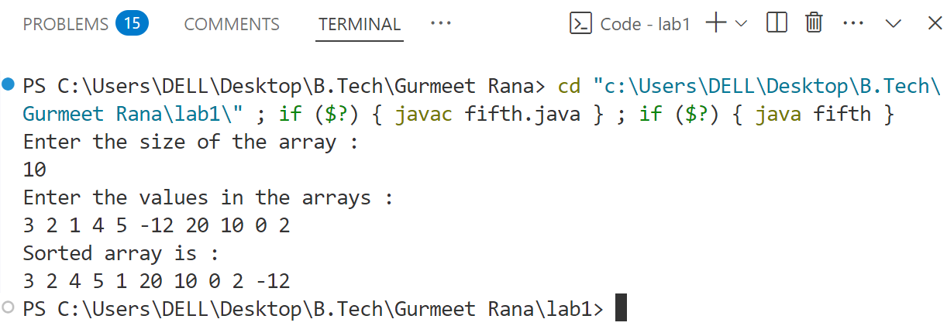

PROGRAM 6 :

SOURCE CODE :

import java.util.Scanner;

public class sixth {

public static void sortNegatives(int arr[],int n)

{

int i=0,j=n-1;

while(i<j)

{

if(arr[i]>0 && arr[j]<0)

{

int temp=arr[i];

arr[i]=arr[j];

arr[j]=temp;

}

i++;

j--;

}

}

public static void main(String [] args)

{

Scanner sc=new Scanner(System.in);

int n;

System.out.println("Enter the size of the array : ");

n=sc.nextInt();

int arr[]=new int[n];

System.out.println("Enter the values in the array : ");

for(int i=0;i<n;i++)

{

arr[i]=sc.nextInt();

}

n=arr.length;

sortNegatives(arr,n);

System.out.println("The sorted array is : ");

for(int i=0;i<n;i++)

{

System.out.print(arr[i]+" ");

}

System.out.println("Exiting the program....");

}

}

OUTPUT :

